Systematic review and meta-analysis of the circulating cathodic antigen (CCA) test in the diagnosis of schistosome infection

Background
Schistosomiasis, caused by blood fluke, a group of flat worms that reside in the blood vessels in the human hosts, remains one of the most prevalent parasitic infections with a significant global public health impact (WHO 2012). The disease is commonly found among low income countries whose health systems face difficulties to provide basic care at the peripheral level where it is most needed (Chitsulo et al. 2000). Five species, namely Schistosoma mansoni, S. haematobium, S. japonicum, S. intercalatum and S. mekongi can infect humans but the three with significant public health impact are S. mansoni (common in the tropics and sub-tropics), S. haematobium (mostly endemic in Africa and the Middle East) and S. japonicum (mainly found in the People’s Republic of China and the Philippines) (WHO 2012). S. mansoni and S. japonicum cause intestinal schistosomiasis whilst S. haematobium causes urogenital schistosomiasis. In Africa, S. mansoni and S. haematobium infections are responsible for most of the disease with an overlap in distribution in some countries resulting in mixed infection in most infected persons.

The infection is acquired when the infective cercariae penetrate a person’s skin upon contact with infested water bodies, rivers or lakes. Eight to ten days post penetration of the host’s skin the worm migrates to the liver sinusoids, then locates and resides in the superior mesenteric veins draining the large intestine (S. mansoni) or draining the small intestine (S. japonicum), or the venous plexus of the urinary bladder (S. haematobium). A schistosome worm reaches maturity within 6-8 weeks. An adult worm usually lives for 3-5 years, but some can live up to 30 years in the human host (Warren 1982) and can theoretically produce up to 600 billion new schistosomes during their life-time (Gryseels et al. 2006). Schistosome infection displays age-intensity profile that is typically convex, with prevalence and intensity of infection rising in school-aged childhood, peaking in adolescence and decreasing in adulthood to a relatively stable phase (King et al. 1988; Mitchell et al. 2008). Preschool children aged up to 5 years usually have light infections compared to school-aged children.

Pathology and clinical morbidity are caused by eggs trapped in host tissues, but not the worms themselves. Symptoms and signs of the disease are location-specific. Within the human body, eggs produced by the worms are moved progressively across the walls of blood vessels towards the lumen of the intestine to be excreted with the faeces (S. mansoni and S. japonicum) or the bladder and ureters for excretion with the urine (S. haematobium). Although most individuals with few schistosome worms, especially adults, remain asymptomatic, about 80% of infected children present with one or more symptoms of the disease in the early stages of the infection (Mott et al. 1983; Gryseels and Polderman 1987; Olds and Dasarathy 2000).

The acquisition of the infection may be followed by an initial acute illness called Katayama’s syndrome within 4-8 weeks characterized by a systemic hypersensitivity reaction, lymphadenopathy and eosinophilia. The main early symptoms of an established disease with intestinal schistosomiasis are non-specific and include abdominal pain, diarrhoea (which can be bloody) and blood in stool (Gryseels et al. 1992; Lengeler 2002). For S. haematobium the main early symptom is blood in the urine (haematuria), appearing within 10-12 weeks of the infection, sometimes accompanied by painful urination (dysuria) (refs).

Globally, an estimated 800 million people are at risk of the infection and 207 million have the disease (Hotez et al. 2006; Steinmann et al. 2006; WHO 2012). A person with schistosomiasis may be re-infected repeatedly even when regular treatment is provided (WHO 2002; King and Dangerfield-Cha 2008), necessitating repeated screening, diagnosis and treatment of endemic populations. High intensities of infection are found in populations whose occupations and livelihood bring them into regular contact with infested water bodies such as lakes and rivers. In such settings, many people acquire infections at a very young age with effects of the disease starting at a very early age. If detected early and treated, the disease may be reversed and pathology or complications may be reversed.

The goal of schistosomiasis control is to prevent new infections or interrupt transmission of the infection, usually by blocking the parasites lifecycle. As this has been difficult to achieve, control guidelines have changed several times over the years. At the same time, several medicines have been tried and abandoned because of poor effect or adverse events. The 1970s marked the turning point in schistosomiasis control when safe and effective medicines were developed and brought on to the market. Praziquantel (PZQ), a broad-spectrum, safe and easy to administer medicine immediately became the treatment of choice for schistosomiasis in the late 1970s (Cioli et al. 1995). Initially earmarked for transmission control, the high price of PZQ made universal coverage impossible. Therefore, WHO issued a guideline that endorsed morbidity control as a new and cost-effective control option (WHO 1985). This approach was to limit coverage of PZQ to symptomatic individuals or those with heavy worm load and likely to suffer complications from the infection. Selective treatment involved the identification of high prevalence communities, screening the people and treating those identified to have the infection (WHO 1985). Since then PZQ has been delivered through small-to-medium, or large-scale selective programmes across endemic countries in sub-Saharan Africa achieving only short-term benefit in prevalence reduction. The long-term outcome has been disappointing as transmission and reinfection rates usually remained unchanged in most treated populations (Chitsulo et al. 2000; Engels et al. 2002).

PZQ use has increased considerably since the early 2000s and in areas where schistosomiasis treatment had not previously reached, now initiated mass-scale treatment campaigns partly due to expiry of patent of PZQ in the early 1990s that allowed the production of several brands bringing the price from about US$1 to less than US$ 0.06 per tablet in the early 2000s (ref). PZQ distribution has increased further following endorsement of Resolution 54.19 at the World Health Assembly (WHA) in 2001 that urged member States to embark on mass treatment of at least 75% of infected school children and high-risk individuals or entire ’at-risk’ populations through the millennium strategy called ‘preventive chemotherapy’ (PCT), usually without diagnosis before treatment. PZQ at a standard single oral 40 mg/kg dose is recommended and applied in the PCT strategy.

In 2002, WHO convened an Expert Committee meeting to develop operational guidelines to translate the recommendations of WHA54.19 into action with emphasis on morbidity control with PZQ using defined prevalence thresholds as criteria (WHO 2002). Since then thousands of school-aged children in endemic countries in SSA have received multiple doses of PZQ, initially through the Schistosomiasis Control Initiative (SCI) which started in 2003 (Fenwick et al. 2006; Fenwick A et al. 2009; Linehan M et al. 2011), then mass drug administration (MDA) delivered through integrated PCT with other neglected tropical diseases (Hotez 2009 2011). Following new evidence that morbidity is not necessarily determined by high levels of infection, led to a revised version of the operational details of PCT in 2006 (WHO 2006).

Within the new PCT strategy, WHO recommends that in low endemicity communities of prevalence <10%, parasitological methods – duplicate 41.7 mg Kato-Katz thick smear (for intestinal schistosmiasis) and standard 10 mL urine filtration (for urogenital schistosomiasis) should be performed for the detection of the infection prior to treatment.

Existing (Alternative) diagnostic tests
The most widely used technique for the diagnosis of schistosome infection is microscopic examination for parasite eggs in stool (S. mansoni and S. japonicum) and urine (S. haematobium). Microscopy can quantify eggs and is recommended for epidemiological purposes because it allows estimation of intensity of infection and evaluation of the impact of control programmes (WHO1985; Doenhoff 2004; Bergquist 2009). The Kato-Katz technique (Katz et al. 1972) that examines stool specimens for presence of eggs, quantifies the infection into intensity categories, is the most commonly used quantitative technique for the diagnosis of intestinal schistosomiasis (Booth 2003). Single or multiple slides may be prepared from a thick smear containing 25 mg of stool (although 41.7 mg is recommended) and examined under a microscope for the presence of schistosome eggs which are multiplied by a factor to obtain egg per gram of stool (EPG). Intensity of infection is then determined based on WHO classification which categorises up to 99 EPG as light infection, 100 to 400 EPG as moderate and >400 EPG as heavy infection. S. haematobium infection is detected by filtration of standard 10 ml of urine through Nucleopore membrane. It is recommended that urine specimen should be collected between 10 am and 2 pm, preferably after physical exercise. Eggs are counted using the microscope, intensity of infection quantified and classified as light if egg count per 10 mL of urine is <50, otherwise heavy infection.

These techniques perform well in the detection of high intensity-infection, have low operational cost and can be used in settings with minimal infrastructure (Rabello 1992). However, sensitivity of parasitological diagnosis by microscopy decreases considerably when egg excretion is low particularly after treatment or when endemicity is low. Accuracy is also influenced by sample preparation methods, and day-to-day variation of egg production and excretion in stool or urine (Braun-Munzinger 1992; Engels 1996; Engels 1997; Igreja et al. 2007; Enk 2008). A modelling exercise has shown that microscopy misses a large proportion of the infection and hence underestimates the true prevalence of schistosomiasis (De Vlas et al. 1992; De Vlas et al. 1997). Demographic factors such as age and sex of the host can affect accuracy of microscopy. Therefore, negative results from microscopic examination of a single stool or urine specimen are not 100% reliable (De Vlas and Gryseels 1992; Gryseels 1996; De Vlas 1997; Utzinger et al. 2001; Booth et al 2003; Enk et al. 2008; Lin et al 2008) as the measurement of prevalence and intensity of infection by egg count has shortcomings.

Recently, the FLOTAC technique based on flotation of schistosome eggs under gravity has been applied for the detection and quantification of S. mansoni eggs in stools showed some initial promise but further investigation is required (Glinz 2010). The FLOTAC technique requires more sophisticated laboratory equipment than the Kato–Katz technique, such as a centrifuge and different chemicals (Utzinger et al. 2011). It has been reported that egg counts using FLOTAC are considerably lower compared with Kato–Katz.

Rectal biopsy for all schistosome species and biopsy of the bladder for S. haematobium are more sensitive and occasionally done when repeated stool or urine examinations are negative for schistosome eggs (Rabello 1992; Yirenya-Tawiah et al. 2011). Rectal biopsies are particularly useful when conducting clinical trials into new treatments when it is necessary to observed egg morphology in tissues. However, biopsies are invasive, cumbersome to perform and expensive, not recommended for mass field application (Allan 2001).

Clinically, schistosomiasis is diagnosed on the basis of blood in the urine of the patient (for S. haematobium) and blood in stool, diarrhoea or abdominal pain (for S. mansoni and S. japonicum). Diagnosis based on presence of blood in urine is reliable in children but tends to be less specific and reliable in adults where blood in the urine may be caused by other diseases, for example, sexually transmitted diseases. Diarrhoea, abdominal pain or blood in stool are also non-specific and could be due to other causes and not necessarily intestinal schistosomiasis. For example, diarrhoea or blood in stool can be due to dysentery.

Questionnaires eliciting answers about presence of specific schistosomiasis-related signs and symptoms are good for rapid and mass screening of schistosome infections in high endemic communities and are considered operationally cost-effective (ref). For urogenital schistosomiasis assessment of haematuria by questionnaire is commonly used as a rapid method for the identification of populations for mass treatment of S. haematobium infection. Whilst questionnaire-based assessment that relies on self-reporting of symptoms is believed to be less reliable given that recall bias can be high, study that compiled evidence on this showed no effect of recall period length on prevalence of self-reported haematuria in S. haematobium-endemic areas (van der Werf et al. 2003). Another study found moderate-to-high sensitivity depending on age and prevalence of the infection when blood in urine and painful urination are used as proxy for S. haematobium infection (Bogoch et al. 2012). Generally, sensitivity and specificity tend to be high in high prevalence areas but low with low prevalence of infection. For urinary schistosomiasis, the simple questionnaire approach is not markedly inferior to the other techniques, making it suitable for use in field situation for mass screening (van der Werf et al. 2003). For intestinal schistosomiasis however, the main signs and symptoms (blood in stool, diarrhoea and abdominal pain) are neither sensitive nor specific (Danso-Appiah et al. 2004, 2010) and questionnaire-based diagnosis is less encouraging (Raso et al. 2005). Another major problem is that questionnaire application is influenced by age and gender of the infected person (ref).

Immune-epidemiological methods
Urine reagent strip tests are used for the detection of haematuria, proteinuria or leukocyturia in the diagnosis of active S. haematobium infection. It is a rapid and indirect assessment of morbidity caused by urogenital schistosomiasis in endemic areas. Micro-haematuria as detected by urine reagent strips predicts well the severity of schistosomiasis-related pathology before and after community-based chemotherapy. Haematuria and proteinuria are good predictive indicators for pathology in a pre-treatment population. Urine dipsticks for detection of micro-haematuria offer an inexpensive means for estimating infection prevalence (King and Bertsch 2013). Dipstick ELISA test is non-invasive, field applicable diagnostic technique specific for detecting S. haematobium antigens in urine (Bosompem et al. 1996a, 1996b). The dipstick ELISA has proved to be more sensitive, specific and rapid than the standard microscopy method (Bosompem et al. 1998). Polymerase chain reaction (PCR) is a molecular biology technique employs genomic parasite DNA extraction from urine and stool samples of schistosome infected persons. PCR has been evaluated in endemic settings for the detection of active schistosome infections and showed to be highly sensitive and specific. However, its use is limited to some reference laboratories in Europe as it requires significant material and human resource (Pontes et al. 2003; Sandoval 2006; Cnops 2012; Enk 2012).

Index tests
Living schistosomes constantly release secretory metabolites which are carried in the host circulation from the point of release. These metabolites were identified as Schistosoma-genus specific circulatory antigens (Berggren and Weller 1967). Two forms of the antigens, circulatory anodic antigen (CAA) (Gold et al. 1969) and circulatory cathodic antigen (CCA) (Deelder et al. 1976) were described. Their presence was demonstrated in adult worm homogenates on the three human schistosome infections that were later linked with active schistosome infections (Kelly 1987). CCA test that relies on the detection of schistosome antigens in serum and urine of patients has the potential to provide more sensitive and rapid testing for schistosome infection. The serum and urine-based CCA-ELISA has been extensively evaluated and applied in many studies with promise for S. mansoni infections, but variable sensitivity for S. haematobium infections (De Jonge et al. 1988, 1989; Kremsner et al. 1994; Van Lieshout et al. 2000). A point-of-care CCA (POC-CCA) has been developed from CCA-ELISA (Van Dam et al. 2004) and performed well for S. mansoni but not consistent with S. haematobium and S. japonicum. It is based on lateral flow assay using a nitrocellulose strip of the sample with a colloidal carbon conjugate of anti-CCA monoclonal antibodies (van Dam et al. 2004). For S. haematobium, CCA shows much more urine variability between geographic regions and performs well only in moderate-to-high infection intensity states (refs). More recently, a rapid, easy to use urine-based POC-CCA cassette test strip (dipstick) suited to field conditions and requiring no laboratory facilities or expert human resource has been developed and field-tested (Navaratnam et al. 2012; more refs). This has led to the discontinued use of the original carbon test strips in favour of the POC cassette test. The POC cassette package consists of 25 test cassettes each individually packaged, 1 user instructions, 3 mL bottle of buffer and 25 urine collection devices (plastic pipettes) corresponding to the number of cassettes (http://www.rapid-diagnostics.com/). The CCA dipstick is scored according to the test band reaction intensity as negative (-), trace positive (tr), single positive (+), double positive (++) and triple positive (+++). Here, POC testing is defined as a test conducted near the site of patient care, or where the patient is located such as in the community, that does not require permanent dedicated space and conducted by non-specialized laboratory healthcare professionals (Price 2001).

Rationale
The WHO strategy for schistosomiasis over the years has been morbidity control based on the detection of heavy infections. For intestinal schistosomiasis, microscopic examination of schistosome eggs by the Kato-Katz method has been the recommended diagnostic technique because of its assumed sensitivity, ease of use in the field and cost. However, the sensitivity of this technique depends on the severity of the infection, and in low grade infections, the sensitivity of one microscopic examination may be as low as 20% (ref). Up to 5 stool specimens collected on different days are recommended to increase the sensitivity of the tests (ref). With the scale up of schistosomiasis treatment and control via mass drug administration (MDA) through Preventive Chemotherapy (PCT) strategy, prevalence and intensity of infection have fallen significantly in most areas such that routinely used diagnostic tests are insensitive. Therefore, there is the need for a rapid, sensitive and easy-to-use at low cost diagnostic technique. Recent studies in settings in Africa have demonstrated that a market-ready urine-based CCA test is much more sensitive than Kato-Katz technique, even though it appears to suffer the same limitation of low sensitivity for low infection intensity (ref). The CCA assay has been evaluated in different settings across geographic locations over the past 30 years and studies have shown that levels in patients with urinary schistosomiasis are variable, and also seem to differ between regions (ref). However, there is no study that has systematically and robustly pooled data in a systematic review to provide reliable evidence on the performance of CCA tests although systematic reviews are widely regarded as the best form of evidence to inform public health decisions (Egger and Davey 1997, Higgins and Green 2011). Systematic reviews provide summaries of evidence contained in a number of individual studies on a specific topic scattered across the literature and bring them together (Khan et al. 2011) rather than looking at any particular study in isolation (Chalmers 2007). Systematic review involves systematically locating, appraising and synthesizing data from a large number of sources (Borenstein et al. 2009). In particular when it involves the statistical dimension, meta-analysis, it can be used to investigate controversies, consistency or differences of effects of an intervention or diagnostic test across a group of studies. By pooling studies, it improves statistical power and provides more precise estimates of the effects of an intervention than those derived from the individual studies. Of note, systematic reviews assess quality or risk of bias in each of the included studies as part of the review process, with the ultimate being that, when well-conducted, systematic reviews provide the best (valid and reliable) evidence on which public health policies can be based. Therefore, it is important to assess comparative effectiveness, applicability and cost of CCA against Kato-Katz technique (for intestinal schistosomiasis) and urine filtration (for urogenital schistosomiasis) in different populations and endemicity settings in a systematic review, before recommendations for its wider use can be made.

Primary objective
To assess the diagnostic accuracy of urine-based point of care- circulating cathodic antigen (POC-CCA) test for the diagnosis of schistosome infections using stool-based Kato-Katz thick smear (for S. mansoni and S. japonicum,) or standard 10 mL urine filtration (for S. haematobium) microscopic examination and detection of schistosome eggs as reference standard.

Secondary objectives
- To assess the performance of ELISA for CCA in serum or urine, or other CCA assays for the diagnosis of schistosome infections.
- To determine the cost of application of POC-CCA in the endemic settings.
- Assess the effect of geographic location, age, endemicity and treatment on performance of CCA.
- To compare time required for preparation and application and patient preference between POC-CCA, Kato-Katz technique and standard 10 mL urine filtrate method*.

*For patient’s acceptability or preference, it is expected that there is no difference between POC-CCA and the standard urine filtration for urinary schistosomiasis as both use urine sample collected in the same format.

Criteria for considering studies for this review

Types of studies

Every study type where the results of the index CCA test have been compared with a reference standard (Kato-Katz or urine filtration, or both) for the diagnosis of active schistosome infection, were eligible for inclusion. Any ‘single-gate’ diagnostic accuracy design that included participants in whom infection status at baseline was unknown, and compared the results of the index test with those of the reference standard test used to confirm the diagnosis, and representing the scenario in which the test would be used, were included. Case-control accuracy studies involving patients with an established diagnosis of the infection were not eligible for inclusion. Cross-sectional and cohort type accuracy studies were eligible for inclusion, and in special cases paired comparisons with a reference standard, for example, tests A and B performed in all patients, and randomised studies of test accuracy were eligible. Studies were excluded if they compared CCA with Formal Ether alone or whole urine concentration because these are not widely acknowledged reference standards for schistosomiasis diagnosis.

Types of participants
Individuals diagnosed microscopically for the presence of schistosome eggs in their stool (for intestinal schistosomiasis due to S. mansoni and S. japonicum) using the Kato-Katz technique (Katz et al. 1972) or in their urine using the standard 10mL urine filtration method (for Urogenital schistosomiasis due to S. haematobium).

Index tests
- The diagnostic test of interest is POC-CCA cassette-based test for the detection of schistosome antigens in urine of patients in endemic settings. The CCA dipstick is scored according to manufacturer-specified test band reaction intensity as negative (-), trace positive (tr), single positive (+), double positive (++) and triple positive (+++).
- ELISA for urine CCA test scored according to manufacturer-specified test band reaction intensity as negative (-), trace positive (tr), single positive (+), double positive (++) and triple positive (+++).

Reference standard
Kato-Katz thick smear
The quantitative Kato-Katz technique (Katz et al. 1972) that examines stool specimens under the microscope for presence of S. mansoni and S. japonicum eggs in the stool of patient (Booth et al. 2003). This technique examines single or multiple slides 25 mg or 41.7 mg of stool (the latter is recommended by WHO). The stool sample is passed through a nylon sieve and is cast on a template onto a glass microscope slide. A cellophane paper soaked in malachite green/ glycerol solution serves to clarify the specimen for microscopy. Eggs detected are multiplied by a factor to obtain egg per gram of stool (EPG) from which intensity of the infection is determined using the WHO classification that defines of up to 99 EPG as light infection, 100 to 399 EPG as moderate and >400 EPG as heavy infection.

Urine filtration
- The quantitative urine filtration through Nucleopore membrane that examines standard 10 mL of urine under the microscope for presence of S. haematobium eggs. It is recommended that urine specimen should be collected between 10 am and 2 pm, preferably after physical exercise. The eggs are captured on the membrane and examined by microscopy; the intensity of infection is expressed as eggs/10ml urine. Intensity of infection is classified as light when egg count is <50, otherwise heavy infection.

- Urine sedimentation may be less expensive to carry out, especially in less endowed settings. It involves centrifuging the urine (at least 10ml) and examining the sediment for the presence or absence of S. haematobium eggs.

Parasitological gold standard
There is no ‘true’ gold standard diagnostic test for schistosomiasis. When using the standard single (41.7 mg) Kato-Katz in most endemic settings, for example, sensitivity, particularly when slides are observed within 1 hour after preparation, has ranged from 25-50% (Utzinger et al. 2001; Booth et al. 2003). Therefore, to evaluate a new test in a low-endemicity schistosomiasis setting, microscopy has to be performed on multiple samples to create a reliable ‘parasitological gold standard’ (Deelder et al. 2012). Otherwise, the high percentage of false-negative egg counts may render any conclusions on the specificity of a new test unreliable. Given the limitations of microscopy, the best way to properly and reliably assess accuracy of schistosomiasis test is to determine the sensitivities of the reference standard (Kato-Katz) and index test (POC-CCA) each versus a combined diagnostic (Kato-Katz plus POC-CCA) to serve as a ‘true’ gold standard (Deelder et al. 2012). In this review, we evaluated POC-CCA against each of the reference standard and wherever possible assessed the reference standard and index test against a ‘parasitological gold standard’ of the combined reference standard and index test considered to have a higher sensitivity than each test independently.

Target condition
- Active S. mansoni infection (classified as light, moderate or heavy infection).
- Active S. haematobium infection (classified as light or heavy infection)
- Active S. japonicum infection (classified as light, moderate or heavy infection)

Search methods for identification of studies
We searched MEDLINE, EMBASE and LILACS from inception to 31st March 2014 for studies assessing the performance of circulating cathodic antigen (CCA) test for the diagnosis of schistosome infections with no date, language, or publication restrictions. We also searched BIOSIS, Web of Science, Google Scholar, Rapid Medical Diagnostics database: http://www.rapid-diagnostics.com/publications.html, African Journals Online, Cochrane Infectious Diseases Group Specialized Register, CENTRAL (The Cochrane Library 2014) and mRCT. The following combination of search terms were used: “schistosomiasis mansoni” OR “schistosomiasis haematobium” OR “schistosomiasis japonicum” OR “Bilharzia” OR “Intestinal schistosomiasis” OR “schistosome” OR “Schistosoma mansoni” OR “Schistosoma haematobium” OR “Schistosoma japonicum” OR “S. mansoni” OR “S. haematobium” OR “S. japonicum” AND “CCA” OR “Circulating Cathodic Antigen” OR “Point of care-CCA” OR “Rapid diagnostic test” OR “Urine dipstick” AND “Sensitivity and Specificity” OR “Diagnostic test accuracy” OR “validity”. As accuracy studies present with lack of suitable methodological search filters, we maximised sensitivity of our search by using free texts based on the index test and target condition. We also hand-checked the reference lists of relevant articles and books, and contacted experts for additional or unpublished studies.

Selection of studies
One author searched the literature and retrieved studies using the aforementioned search strategy. Two authors screened the results to identify potentially relevant studies, obtained full trial reports and assessed the eligibility of studies for inclusion in the review using eligibility form based on the predefined inclusion criteria. Any discrepancies were resolved through discussion between the authors.

Data extraction and management
Study characteristics such as citation, country and year study was conducted, study design and methods were recorded on standard forms. Information on the diagnostic criteria of the index test (CCA) such as type, whether POC-based test, manufacturer, number of urine samples tested and threshold classification (trace, +, ++, or +++ according to manufacturer’s instructions and specification using a colour chart supplied with the dipsticks). For the Kato-Katz thick smear reference standard, data extracted included number of stool samples per participants, number of slides and volume of stool examined as well as how intensity of infection was classified (low, moderate and high). For urine specimens, data on volume, time of day urine was samples were collected, number of urine specimens, and categorization (low and high) were extracted. For microscopy we extracted information on whether egg count was expressed as arithmetic or geometric mean, and whether egg per gram of stool (EPG) was based on only positives or positives plus negatives, and recorded missing test results. We extracted epidemiologic and demographic data including endemicity status, region where the study was conducted, participants’ prior treatment status, target population (preschool-aged children, school-aged children, adults, whole population or representative sub-sample), sex and age distribution and study size. Where necessary, we extracted information on cost, level of training and experience of technician and whether diagnostic technique was delivered in the field or laboratory setting. We extracted data on true positives (TP: those that have the disease and tested positive), false positives (FP: those that do not have the disease and tested positive), true negatives (TN: those that do not have the disease and tested negative), and false negatives (FN: those that have the disease and tested negative) to populate the 2 x2 tables (see table below).

Figure 1 2x2 Table for the calculation of sensitivity and specificity

 |  |  |  |  |  | Reference test
 |  |  | Positive |  |  |  | Negative
Index test | Positive |  |  | TP |  |  |  | FP |  |  | TP+FP
Index test | Negative |  |  | FN |  |  |  | TN |  |  | FN+TN
 |  | TP+FN |  |  |  |  | FP+TN |  |  |  | TP+FP+FN+TN
 |  | Sensitivity = |  |  | TP |  | Specificity = |  |  | TN
 |  |  |  |  | (TP+FN) |  |  |  |  | TN+FP

Authors of primary studies were contacted clarification for unclear or insufficient data. Where possible, we obtained raw data from primary study authors for the calculation of quantifications needed to populate the 2x2 contingency table. For studies that provided categorical data based on intensity of infection classification or thresholds, we extracted numbers of index test positive and negative participants using the thresholds defined in the review protocol. If two or more communities were involved in the study, data were extracted for each community, with a link to the parent study. Two authors extracted data and cross-checked for any errors. Disagreements were resolved through discussion.

Diagnostic thresholds
- The index test (CCA) for all schistosome infections is defined on the following thresholds: trace positive (tr), single positive (+), double positive (++) and triple positive (+++).
- The reference standard for S. mansoni and S. japonicum is Kato-Katz thick smear (41.7 mg of stool) defined on the intensity of infection thresholds using the WHO classification as follows: light infection (<100 EPG), moderate infection (100-399 EPG) and heavy infection (>400 EPG).
- The reference standard for S. haematobium is defined on the intensity of the infection thresholds using the WHO classification as follows: light infection (≤50 eggs/10mL of urine) and heavy infection (>50 eggs/10mL of urine).

Assessment of methodological quality
The modified Quality Assessment of Diagnostic Accuracy Studies (QUADAS-2) tool (Whiting et al. 2011) was used to assess risk of bias in four key domains: patient selection, index test, reference standard and flow and timing. Each domain was assessed in terms of risk of bias; the first three also assessed concerns about applicability using signalling questions to help judge the risk of bias by flagging aspects of the study design related to the potential for bias. Risk of bias in each included study was judged as “low,” “high,” or “unclear.” If the answers to all signalling questions for a domain were “yes,” then risk of bias was judged low. If any signalling question was answered “no,” potential for bias could exist. The “unclear” category was used only when insufficient data were reported that would not allow a full judgment to be made. The results of quality assessment have been presented as text and graphical representation. Disagreements were resolved through consensus or by a third author. The Standards for the Reporting of Diagnostic Accuracy Studies (STARD) checklists, which is made up of 25 questions of yes/no answers weighted equally (yes = 1 and no = 0) was used to guide reporting of risk of bias in the included studies. The total score for each study calculated and reported.

Data synthesis
Sensitivity, specificity, false positive rate, positive and negative likelihood ratios, with their 95 % confidence intervals (CI), were analysed and presented together with Summary Receiver Operating Characteristics (SROC) curves. The meta-analyses were performed using the bivariate model specified in Reitsma et al (2005), using the Mada package in the R programming environment. A continuity correction of 0.5 was added to all cell values. The function fits the bivariate model of Reitsma et al. (2005) that Harbord et al (2007) have shown to be equivalent to the HSROC (Hierarchical Summary Receiver Operating Characteristics) of Rutter & Gatsonis (2001). We specify the model as a linear mixed model with known variances of the random effects, similar to the computational approach by Reitsma et al (2005). Variance components are estimated by restricted maximum likelihood (REML) as a default but maximum likelihood estimation is also available. In addition meta-regression is possible and the use of other transformations than the logit, using the approach of Doebler et al (2012). The bivariate meta-regression was conducted using random effects approach incorporating the amount of correlation between sensitivity and specificity across studies. A p-value below 0.05 was used to test statistical significance. In order to remove the need to adjust for confounders, the analysis was restricted to studies that evaluated both index and reference standard tests in the same patients. Sub-group effects were investigated by stratifying the analyses by age (preschool children and infants, school- aged children and adults), sensitivity of reference standard and background endemicity measured by prevalence of the infection: low, moderate and high (for intestinal schistosomiasis) and low and high (for urinary schistosomiasis).

Assessment of heterogeneity and sub-group analysis
We assessed heterogeneity by inspecting the forest plots for overlapping CIs and outlying data; using the Chi² test with a P value < 0.1 to indicate statistically significant heterogeneity; and using the I² statistic. Methodological and clinical differences such as patient populations (preschool-aged children, school children, or adults), tests type, study design type and robustness of conduct of study were considered in addition to the aforementioned statistical measures. I-squared (I²) test gives a better measure of the consistency between studies in a meta-analysis (Higgins and Thompson 2002, Higgins et al. 2003). I² describes the percentage of total variation across studies that is due to heterogeneity rather than chance (Higgins et al. 2003, Higgins and Green 2009). Negative values of I² were put equal to zero so that I² lied between 0% and 100%. A value of 0% indicates no observed heterogeneity, and larger values show increasing heterogeneity. Heterogeneity cross studies is low when I² is up to 25%, moderate (I²= 50%) and high for I² values of 75%). When significant heterogeneity was detected, we carried out subgroup analyses to explore potential causes. Subgroupings followed patient age (children versus adults); and intensity of infection (< 400 epg of stool versus > 400 epg of stool). Where meta-analysis was not considered clinically or statistically meaningful by virtue of high levels of heterogeneity, we did not pool data in a meta-analysis but conducted narrative synthesis of the evidence.

Results
Twenty seven studies (???? participants) published in 20 articles met the inclusion criteria (see Table 2?? Characteristics of included studies). The studies were all from Africa, East Africa (), West Africa (), North Africa (), Central Africa () and Southern Africa (). …use POC-CCA cassette whilst used an older version of CCA. Twenty-five of the studies assessed CCA for the diagnosis of S. mansoni infection whilst 2 studies assessed performance of CCA for the detection of S. haematobium infection. Four studies were conducted in the 1990s, … studies in the early millennium whilst …were conducted over the last 5-6 years. Most of the studies come from East Africa and non from North Africa. None of the studies was a randomized control trial, all are cross-sectional studies.

One publication (Colley et al 2013) reporting primary data of multi-country studies was included because some of the data reported were not available in the individual country studies.

TO COMPLETE DESCRIPTIVE RESULTS
Figure 1 Flow diagram of the study selection process

Identification
Records identified through database search (n=4500)
Additional identified through other sources (78)

Screening
Citations retrieved (n=4578)

Excluded through duplication (n=65)

Records screened (n=4513)

Analysed
S. mansoni (n= 25 studies)

S. haematobium (n=2 studies)
S. japonicum (n=0)
Eligibility
Included
Full text articles assessed for eligibility (n=123)
20 published articles made up of 27 studies
Excluded (n=4390)
Excluded with reasons (n= 103)
- Not primary data = 61
- Inappropriate reference = 18
- Inappropriate participants = 12
- Insufficient data to populate the 2x2 table= 9
- Case control study= 3

1. SINGLE POC-CCA TEST VERSUS STANDARD KATO-KATZ REFERENCE TEST

Performance of single POC-CCA test compared to Kato-Katz reference standard ((41.7 mg duplicate slides) for the detection of S. mansoni infection were investigated by seven studies (Shane et al. 2011; Tchuem Tchuente et al. 2012; Coulibaly et al. 2011; Adriko et al. 2014; Erko et al. 2013; Standley et al. 2010; Sousa-Figueiredo et al. 2013) from Kenya, Cameroon, Cote d'Ivoire, Uganda, Ethiopia, Kenya and Uganda. The meta-analysis showed pooled sensitivity of the POC-CCA index test to be 0.90 [95% CI 0.84 to 0.94] and specificity to be 0.56 [95% CI 0.54 to 0.61] (Analysis 1). From the analysis, there appeared to be some variation in specificity of POC-CCA but sensitivity appeared relatively stable across the independent studies.

Analysis 1: Diagnostic accuracy of single POC-CCA versus Kato-Katz reference standard for the detection of S. mansoni infection
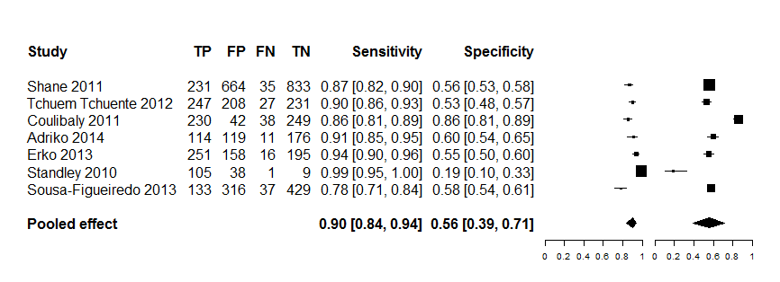

For POC-CCA, trace was considered as positive.
Kato-Katz consisted of single stool with duplicate slides (41.7mg of stool sample each).
Data points for Shane 2011, Tchuem Tchuente 2012 and Erko 2013 were extracted from Colley et al. 2013 that reported primary data from a multi-country study in Africa.
Analysing based on a summary of ROC from sensitivity versus false positive rate (1-specificity) of the test resulted in diagnostic accuracy measured by area under curve (AUC) of 0.86 (Figure 1). Similar to the results of the forest plot in Analysis 1, clearly, there is wide variation in 1-specificity (false positive rate) of POC-CCA for detecting S. mansoni infection as depicted by the individual eclipses under the ROC space.

Figure 1: Diagnostic accuracy of single POC-CCA versus Kato-Katz reference standard for the detection of S. mansoni infection from SROC curve
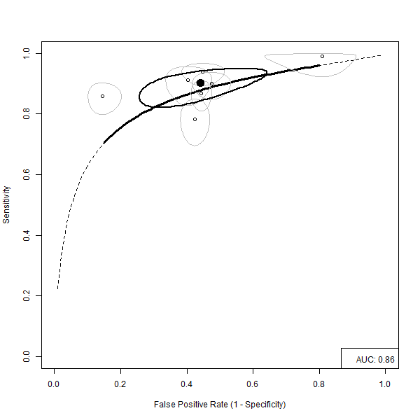

For POC-CCA, trace was considered as positive.
Kato-Katz consisted of single stool with duplicate slides (41.7mg of stool sample each).Data points for Shane 2011, Tchuem Tchuente 2012 and Erko 2013 were extracted from Colley et al. 2013 that reported primary data from a multi-country study in Africa.

2. SINGLE POC-CCA TEST VERSUS KATO-KATZ REFERENCE
The performance of single POC-CCA test was compared with Kato-Katz test from three consecutive stools (41.7 mg duplicate) for the detection of S. mansoni infection. Fourteen studies (Colulibaly 2011-study 1, Coulibaly 2011-study 2, Coulibaly 2011-study 3, Dawson 2013, Erko 2013, Legesse 2008, Tchuem Tchuente 2012-study 1, Tchuem Tchuente 2012-study 2, Tchuem Tchuente 2012-study 3, Koukounari 2013-study 1, Koukounari 2013-study 2, Legesse 2007, Coulibaly 2013, Adriko 2014), all from Africa, investigated this and showed pooled sensitivity of 0.85, 95% CI 0.80 to 0.88) and pooled specificity (0.66, 95% CI 0.54 to 0.76). Confidence intervals of some of the studies were wide reflecting small sample sizes. Whilst sensitiity estimates showed some consistency, there was huge variation in specificity in POC-CCA test.
Analysis 2: Single POC-CCA test versus three Kato-Katz test for the detection of S. mansoni infection.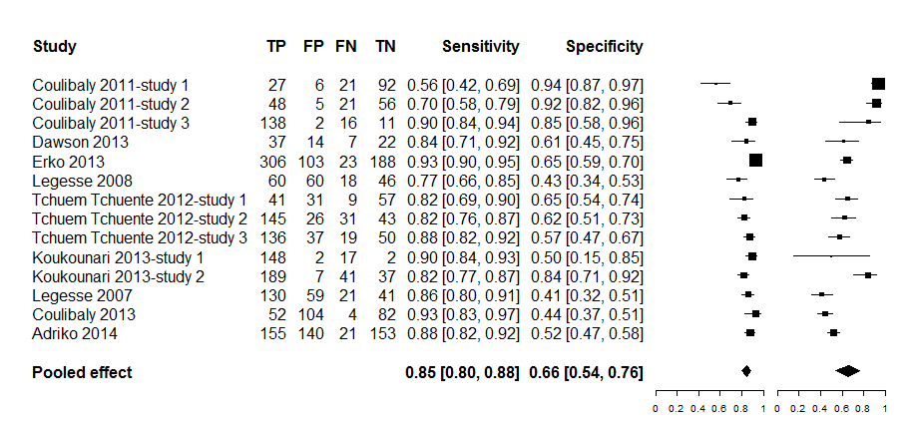

Kato-Katz consisted three consecutive stools of duplicate slides each of 41.7 mg
Dawson (2013) used Kato-Katz from two consecutive stools
Legesse 2007 and Legesse 2008 used an older version of POC-CCA reagent strips () with combined Kato-Katz and Formal Ether concentration test as reference standard
All other studies used POC-CCA cassette test (manufacturer: Rapid Medical Diagnostics, Pretoria, South Africa)
Koukounari 2013-study 1 and Koukounari 2013-study 2 involved separate data for children (7-16 years) and adults (≥ 17 years) so we reported tem separately as data independent studies in the analysis

From SROC curve involving the fourteen studies from Analysis 1, the overall sensitivity in the detection of S. mansoni infection was fairly consistent except two studies that appear to show some degree of variation. On the other hand, there appears to a considerable variation in false positive rate by POC-CCA in the detection of S. mansoni infection as seen from the eclipses spreading across from left to right of the ROC space (Figure 2). The overall accuracy of POC-CCA from AUC is estimated to be 0.85.

Figure 2: SROC curve of single POC-CCA test versus three Kato-Katz tests as reference standard
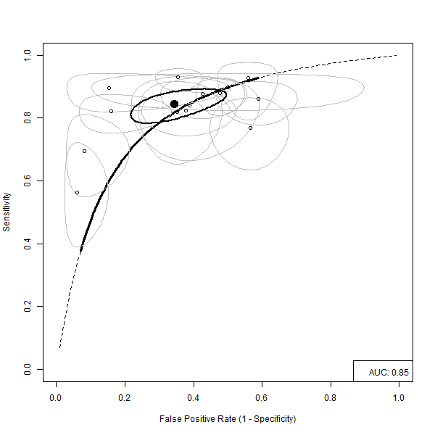

Kato-Katz consisted three consecutive stools of duplicate slides (41.7 mg each)
Dawson (2013) used Kato-Katz from two consecutive stools
Legesse 2007 and Legesse 2008 used an older version of POC-CCA reagent strips (…) with combined Kato-Katz and Formal Ether concentration test as reference standard
All other studies used POC-CCA cassette test (manufacturer: Rapid Medical Diagnostics, Pretoria, South Africa)
Koukounari 2013-study 1 and Koukounari 2013-study 2 involved separate data for children (7-16 years) and adults (≥ 17 years) so we reported tem separately as data independent studies in the analysis
3. THREE POC-CCA TESTS VERSUS THREE KATO-KATZ
Eight studies, four from the same author from Cote d’Ivoire (Coulibaly 2011-study 1, Coulibaly 2011-study 2, Coulibaly 2011-study 3, Coulibaly 2013), three from the same author from Cameroon (Tchuem Tchuente 2012-study 1, Tchuem Tchuente 2012-study 2, Tchuem Tchuente 2012-study 3) and one from Ethiopia (Erko 2013) assessed the performance of three POC-CCA tests versus Kato-Katz tests from three consecutive stools (duplicate 41.7 mg) for the detection of S. mansoni infection. The meta-analysis showed pooled sensitivity of POC-CCA to be 0.91 [95% CI 0.84 to 0.95] and specificity 0.56 [95% CI 0.39 to 0.72] (Analysis 3). Sensitivity showed to be fairly consistent across studies but pooled specificity has wide confidence interval and a degree of variability across studies.

Analysis 3: Comparison of three POC-CCA tests with Kato-Katz from three consecutive stools for the detection of S. mansoni infection.
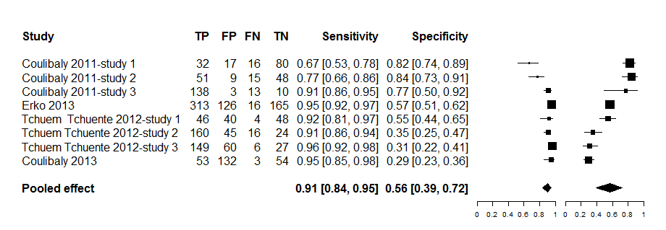

Coulibaly 2013 used duplicate instead of three POC-CCA cassette tests, the rest of the studies assessed three POC-CCA tests.
Coulibaly 2013 also used two consecutive stools for Kato-Katz tests, the rest of the studies used three consecutive stools.
For POC-CCA test, trace was considered as positive test

Figure 3: Summary Receiver Operating Characteristics for the performance POC-CCA from three consecutive urine tests versus Kato-Katz from three consecutive stools, for the detection of S. mansoni infection
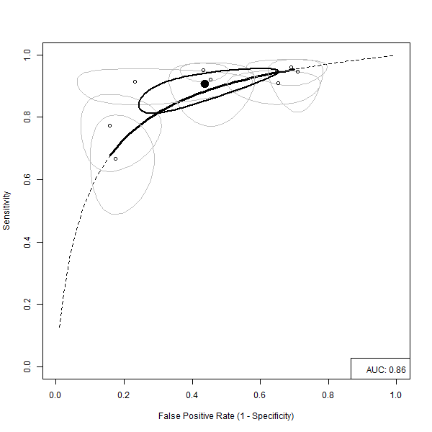
The summary Receiver Operating Characteristics produced an area under the curve of 0.86 (Figure 3).

4: POC-CCA REAGENT STRIP VERSUS STANDARD 10 mL URINE FILTRATION
The performance of POC-CCA was assessed for the detection of S. haematobium infection in two locations in Ethiopia (East Africa) and Zimbabwe (Southern Africa) with mixed results, but pooling involved only two studies. POC-CCA achieved pooled sensitivity of 0.66 [95% CI 0.37 to 0.87, …participants] and specificity 0.54 [95% CI 0.34 to 0.73] with wide confidence intervals around the pooled estimates. There appears to be conflicting evidence in the sense that study in Zimbabwe (Midzi 2009) produced reasonably higher sensitivity (0.79, 95% CI 0.70 to 0.85) and lower specificity (0.44, 95% CI 0.37 to 0.52) but the study in Ethiopia (Ayele 2008) showed very low sensitivity (0.52, 95% CI 0.42 to 0.62) but relatively higher specificity (0.64, 95% CI 0.54 to 0.72). The studies though were conducted before 2007 and used relatively older version of CCA develped by the European Vertinary Laboratory, Woerden, Holland.
Analysis 4: Performance of POC-CCA strips versus standard 10 mL urine filtration for the diagnosis of urinary schistosomiasis
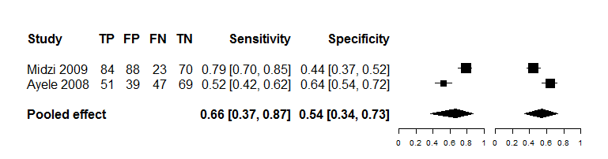

POC-CCA reagent strips based on van Dam et al.2004 with trace counted as positive test

The SROC curve shows an AUC of 0.62 and demonstrates a low … (Figure 4)

Figure 4: Performance of POC-CCA strips versus standard 10 mL urine filtration for the diagnosis of urinary schistosomiasis
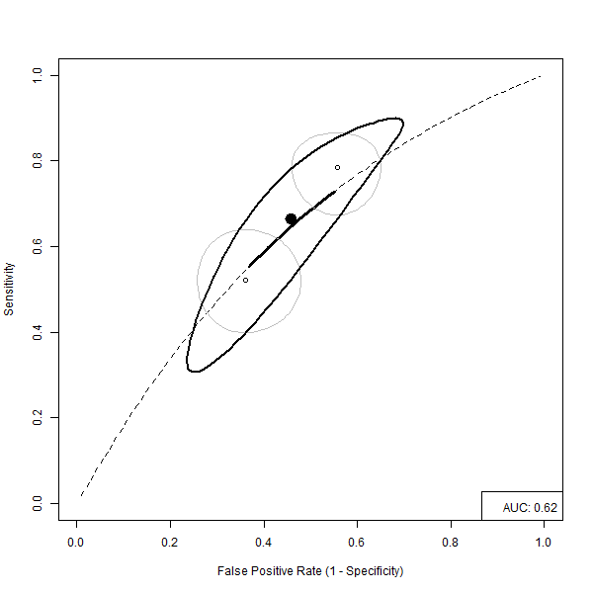
POC-CCA reagent strips based on van Dam et al.2004 with trace counted as positive test

5. GLOBAL COMPARISON BETWEEN POC-CCA AND KATO-KATZ
Nineteen studies were combined in the meta-analysis for the assessment of single and multiple POC-CCA (up to three tests) versus single and multiple Kato-Katz (up to three tests) for the diagnosis of S. mansoni infection and the results showed pooled sensitivity and specificity of 0.85 [95% CI 0.80 to 0.88] and 0.60 [95% CI 0.50 to 0.69], respectively. Confidence intervals of most of the study estimates are wide reflecting possible small sample sizes. The plot shows sensitivity to be fairly consistent across studies, but specificity appears to show a considerable degree of variability across the studies (Analysis 5).

Analysis 5: Global assessment of diagnostic accuracy of POC-CCA and Kato-Katz tests for the diagnosis of S. mansoni infection
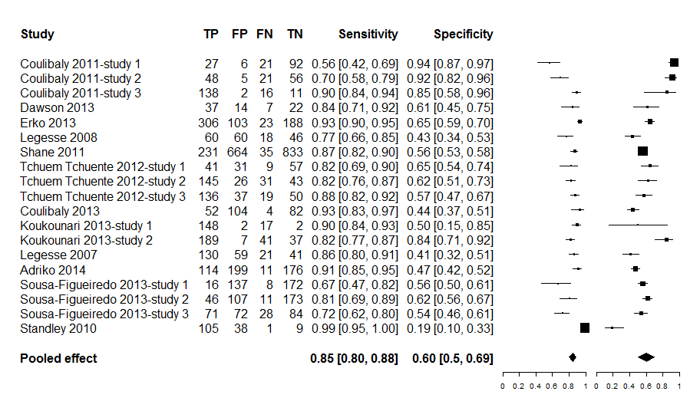

Studies included in this analysis had both index and reference tests examined in the same participants at the same time
Where a study assessed single, two, or three POC-CCA, the results of the single POC-CCA was. Single POC-CCA test were chosen for the analysis from Erko 2013 and Tchuem Tchuente 2012 study1, 2 & 3
For POC-CCA test, trace was considered as positive
Where a study assessed single, two or three Kato-Katz, single Kato-Katz (duplicate 41.7 mg) was chosen as reference standard in conformity with what WHO recommends within the MDA/PCT Strategy. Single Kato-Katz was chosen for the analysis from Erko 2013
If different settings were involved in a study published as one article but reported results for the separate settings, the different settings were included as separate data points. Coulibaly 2011 was classified as Coulibaly 2011 -study 1, 2 & 3 and Tchuem Tchuente 2012 as Tchuem Tchuente 2012 -study 1, 2 & 3)
Children and adults data reported separately were considered as separate datapoints in this analysis (Koukounari 2013)

The global assessment of POC-CCA test accuracy for the diagnosis of S. mansoni infection by ROC model shows variable performance. The AUC representing the overall accuracy of the test is 0.82, but the data demonstrate heterogeneity as shown on the SROC space with the degree of variability relatively higher for specificity (Figure 5).

Figure 5: Performance of single and multiple POC-CCA compared with single and multiple Kato-Katz test for the diagnosis of S. mansoni infection
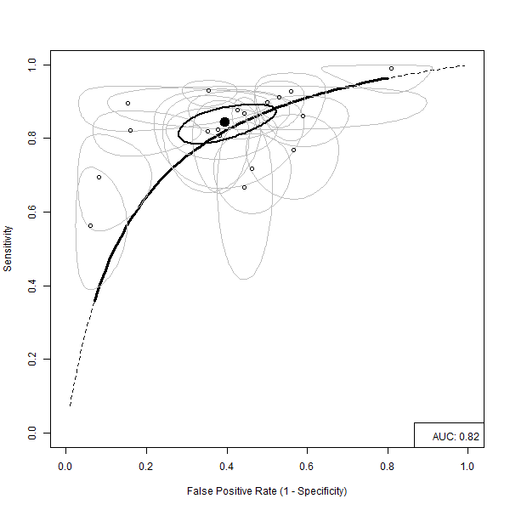

Studies included in this analysis had both index and reference tests examined in the same participants at the same time
Where a study assessed single, two, or three POC-CCA, the results of the single POC-CCA was. Single POC-CCA test were chosen for the analysis from Erko 2013 and Tchuem Tchuente 2012 study1, 2 & 3
For POC-CCA test, trace was considered as positive
Where a study assessed single, two or three Kato-Katz, single Kato-Katz (duplicate 41.7 mg) was chosen as reference standard in conformity with what WHO recommends within the MDA/PCT Strategy. Single Kato-Katz was chosen for the analysis from Erko 2013
If different settings were involved in a study published as one article but reported results for the separate settings, the different settings were included as separate data points. Coulibaly 2011 was classified as Coulibaly 2011 -study 1, 2 & 3 and Tchuem Tchuente 2012 as Tchuem Tchuente 2012 -study 1, 2 & 3)
Children and adults data reported separately were considered as separate datapoints in this analysis (Koukounari 2013)
6: ASSESSMENT OF POC-CCA BY BACKGROUND ENDEMICITY

a) Low endemicity
Four studies (Adriko 2014, Sousa-Figueiredo 2013, Tchuem Tchuente 2012, Coulibaly 2011) assessed the effect of low endemicity on diagnostic performance of POC-CCA. After combining the studies in a meta-analysis, the pooled sensitivity of POC-CCA was 0.69 [95% CI 0.56 to 0.79] lower than specificity 0.78 [95% CI 0.54 to 0.91] (Analysis 6). The confidence intervals of the pooled sensitivity and specificity are somehow wide, particularly for specificity.

Analysis 6a: Performance of POC-CCA in low endemicity settings for the detection of S. mansoni infection
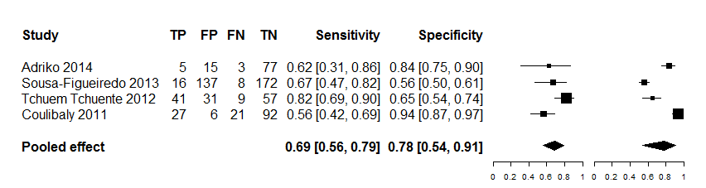
Kato-Katz was used as the reference standard
Low endemicity was defined based on WHO classification

The effect of low endemicity was also analysed from four studies using ROC curve and showed variation, particularly in sensitivity of the test in the ROC space (Figure 6). The diagnostic accuracy as measured by AUC under the ROC space was estimated to be 0.76.

Figure 6a: SROC curve of accuracy of POC-CCA for the detection of S. mansoni infection in low endemicity settings with standard Kato-Katz as reference standard
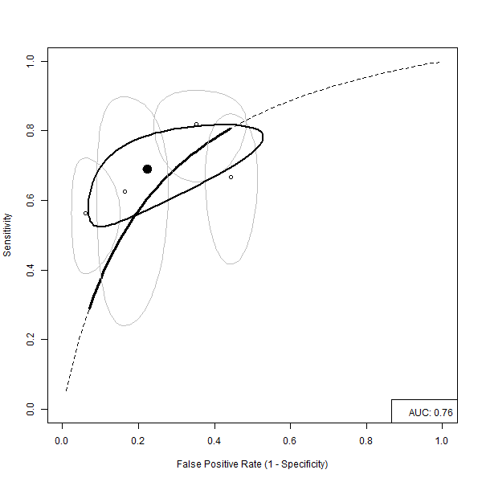
b) Moderate to high endemicity
The four studies that assessed the effect of low endemicity on diagnostic performance of POC-CCA (Adriko 2014, Sousa-Figueiredo 2013, Tchuem Tchuente 2012, Coulibaly 2011) assessed effect of moderate to high endemicity on POC-CCA performance. The results show pooled sensitivity of 0.81 [95% CI 0.76 to 0.85] and specificity of 0.74 [95% CI 0.55 to 0.87]. Pooled sensitivity is high and consistent across studies but specificity shows some variation and somehow wide confidence interval around the pooled estimate (Analysis 6b).

Analysis 6b: Performance of POC-CCA for the detection of S. mansoni infection in moderate to high endemicity settings using Kato-Katz reference standard
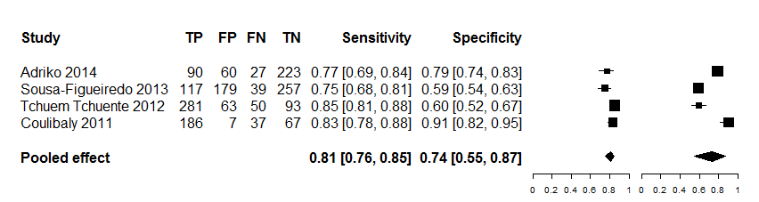

The effect of moderate to high endemicity was analysed from four studies (Adriko 2014, Sousa-Figueiredo 2013, Tchuem Tchuente 2012, Coulibaly 2011) and although there appears to be some variation across studies, this is higher for specificity than sensitivity (Figure 6b). The diagnostic accuracy as measured by AUC under the ROC space is high (0.76).

Figure 6b: SROC of POC-CCA for the detection of S. mansoni infection in moderate to high endemicity settings with standard Kato-Katz as reference standard
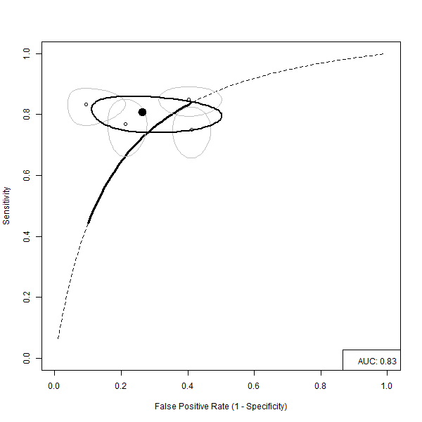

7. ASSESSMENT OF THRESHOLD EFFECT OF POC-CCA

7a) POC-CCA trace as positive versus Kato-Katz reference standard
The four studies conducted between 2009 and 2011, two from Uganda (Adriko 2014, Sousa-Figueiredo 2013), one from a village along the Lake Victoria shoreline of the Tanzanian-Kenyan border (Standley 2010) and one study from Cote d’Ivoire (Coulibaly 2013) assessed the impact of considering trace of POC-CCA test as positive on the diagnosis of S. mansoni infection (Analysis 7a). The combined studies showed an overall high sensitivity (0.93, 95% CI 0.74 to 0.99) of the POC-CCA test but very low specificity (0.42, 95% CI 0.28 to 0.58). From the confidence intervals of the independent studies included in this analysis, except the study by Sousa-Figueiredo 2013, sensitivity appeared to be consistent across the studies. Although the overall pooled specificity was low, one study (Standley 2010) reported unusually low specificity (0.19, 95% CI 0.10 to 0.33), but this is not expected to have affected the magnitude of the overall specificity as the study contributed only small weight to the pooled estimate.

Analysis 7a: Assessment of POC-CCA trace as positive on the diagnosis of S. mansoni infection
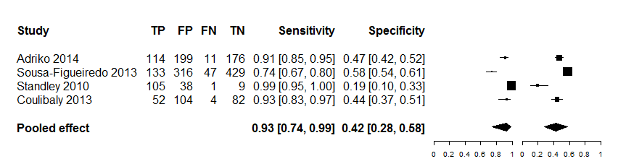

Adriko 2014, Sousa-Figueiredo 2013 and Standley 2010 assessed single POC-CCA versus Kato-Katz (41.7 mg duplicate) from a single stool
Coulibaly 2013 assessed two POC-CCA tests versus Kato-Katz (41.7 mg duplicate) from two consecutive stools

7a) POC-CCA trace as positive versus Kato-Katz reference standard

When the studies (Adriko 2014, Coulibaly 2013, Sousa-Figueiredo 2013, Standley 2010) were analysed using ROC curve that showed specificity from all the studies located to the right corner of the ROC space to suggest its low effect for the diagnosis of S. mansoni infection (Figure 7a). The diagnostic accuracy as measured by AUC under the ROC space was low (0.66).

Figure 7a: Summary ROC of POC-CCA for the detection of S. mansoni infection when trace is considered as positive
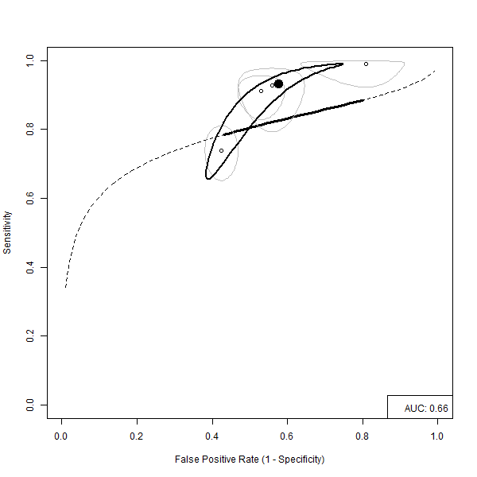

Adriko 2014, Sousa-Figueiredo 2013 and Standley 2010 assessed single POC-CCA versus Kato-Katz (41.7 mg duplicate) from a single stool
Coulibaly 2013 assessed two POC-CCA tests versus Kato-Katz (41.7 mg duplicate) from two consecutive stools

7b) POC-CCA trace as negative versus Kato-Katz reference standard
The four studies analysed in Figure 7a (Adriko 2014, Coulibaly 2013, Sousa-Figueiredo 2013, Standley 2010) also assessed the effect of counting trace of POC-CCA test as negative for the diagnosis of S. mansoni infection and showed lower pooled sensitivity (0.75, 95% CI 0.58 to 0.86) but improved specificity (0.79, 95% CI .073 to .085) compared to when trace is considered as positive (Analysis 7b). The confidence interval for the pooled sensitivity is somehow wide suggesting some degree of uncertainty in sensitivity when trace of POC-CCA test is considered as negative. The study from the Kenya-Tanzania shoreline district of Lake Victoria (Standley 2010) showed the biggest variation in both sensitivity and specificity.

Analysis 7b: Assessment of POC-CCA trace as negative on the diagnosis of S. mansoni infection
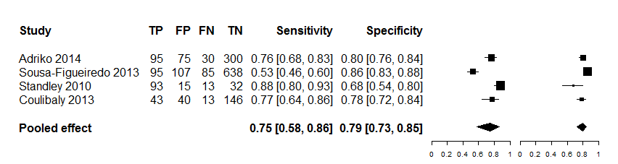

Adriko 2014, Sousa-Figueiredo 2013 and Standley 2010 assessed single POC-CCA versus Kato-Katz (41.7 mg duplicate) from a single stool
Coulibaly 2013 assessed two POC-CCA tests versus Kato-Katz (41.7 mg duplicate) from two consecutive stools

7b) POC-CCA trace as negative versus Kato-Katz reference standard

The studies (Adriko 2014, Coulibaly 2013, Sousa-Figueiredo 2013, Standley 2010) were further analysed using ROC curve and showed AUC under the ROC space of 0.84 (Figure 7b).

Figure 7b: Summary ROC of POC-CCA for the detection of S. mansoni infection when trace is
Considered as negative
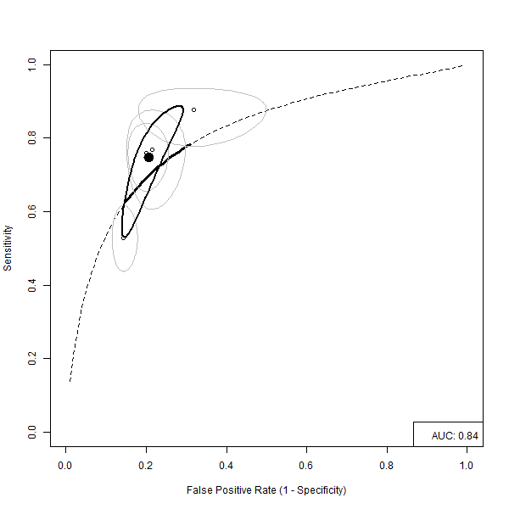

Adriko 2014, Sousa-Figueiredo 2013 and Standley 2010 assessed single POC-CCA versus Kato-Katz (41.7 mg duplicate) from a single stool
Coulibaly 2013 assessed two POC-CCA tests versus Kato-Katz (41.7 mg duplicate) from two consecutive stools

8. ASSESSMENT OF POC-CCA AGAINST A COMBINED GOLD STANDARD

9. PERFORMANCE OF POC-CCA BEFORE AND AFTER TREATMENT

10. ASSESSMENT OF COST OF APPLICATION OF POC-CCA
Cost of 41.7 mg single Kato-Katz thick smear ($1.73) and duplicate ($2.06) within epidemiological survey in Zanzibar (Speich et al. 2010, cited in Utzinger et al. 2011, Acta Tropica S121-S137)

Discussion

Summary of main results

Strengths and weakness of the review

Applicability of findings to the review

Authors’ conclusions

Implications for practice

Implications for research

References:

Included studies
1. Adriko M, Standley CJ, Tinkitina B, Tukahebwa EM, Fenwick A, Fleming FM, Sousa-Figueiredo JC, Stothard JR⁷, Kabatereine NB⁸. Evaluation of circulating cathodic antigen (CCA) urine-cassette assay as a survey tool for Schistosoma mansoni in different transmission settings within Bugiri District, Uganda. Acta Trop. 2014. pii: S0001-706X(14)00114-4.
2. Ayele B, Erko B, Legesse M, Hailu A, Medhin G. Evaluation of circulating cathodic antigen (CCA) strip for diagnosis of urinary schistosomiasis in Hassoba school children, Afar, Ethiopia. Parasite. 2008, 15(1):69-75.
3. Colley DG, Binder S, Campbell C, King CH, Tchuem Tchuenté LA, N'Goran EK, Erko B, Karanja DM, Kabatereine NB, van Lieshout L, Rathbun S. A five-country evaluation of a point-of-care circulating cathodic antigen urine assay for the prevalence of Schistosoma mansoni. Am J Trop Med Hyg. 2013, 88(3):426-32.
4. Coulibaly JT, N'Gbesso YK, Knopp S, N'Guessan NA, Silué KD, van Dam GJ, N'Goran EK, Utzinger J. Accuracy of urine circulating cathodic antigen test for the diagnosis of Schistosoma mansoni in preschool-aged children before and after treatment. PLoS Negl Trop Dis. 2013, 7(3):e2109.
5. Coulibaly JT1, Knopp S, N'Guessan NA, Silué KD, Fürst T, Lohourignon LK, Brou JK, N'Gbesso YK, Vounatsou P, N'Goran EK, Utzinger J. Accuracy of urine circulating cathodic antigen (CCA) test for Schistosoma mansoni diagnosis in different settings of Côte d'Ivoire. PLoS Negl Trop Dis. 2011, 5(11):e1384. doi: 10.1371/journal.pntd.0001384.
6. Dawson EM, Sousa-Figueiredo JC, Kabatereine NB, Doenhoff MJ, Stothard JR. Intestinal schistosomiasis in pre school-aged children of Lake Albert, Uganda: diagnostic accuracy of a rapid test for detection of anti-schistosome antibodies. Trans R Soc Trop Med Hyg. 2013, 107(10):639-47.
7. De Clercq D¹, Sacko M, Vercruysse J, vanden Bussche V, Landouré A, Diarra A, Gryseels B, Deelder A. Assessment of cure by detection of circulating antigens in serum and urine, following schistosomiasis mass treatment in two villages of the Office du Niger, Mali. Acta Trop. 1997, 68(3):339-46.
8. De Clercq D, Sacko M, Vercruysse J, vanden Bussche V, Landouré A, Diarra A, Gryseels B, Deelder A Assessment of cure by detection of circulating antigens in serum and urine, following schistosomiasis mass treatment in two villages of the Office du Niger, Mali. Acta Trop. 1997, 68(3):339-46.
9. Erko B, Medhin G, Teklehaymanot T, Degarege A, Legesse M. Evaluation of urine-circulating cathodic antigen (Urine-CCA) cassette test for the detection of Schistosoma mansoni infection in areas of moderate prevalence in Ethiopia. Trop Med Int Health. 2013, 18(8): 1029–1035.
10. Koukounari A, Donnelly CA, Moustaki I, Tukahebwa EM, Kabatereine NB, Wilson S, Webster JP, Deelder AM, Vennervald BJ, van Dam GJ. A latent markov modelling approach to the evaluation of circulating cathodic antigen strips for schistosomiasis diagnosis pre- and post-praziquantel treatment in Uganda. PLoS Comput Biol. 2013, 9(12):e1003402.
11. Kremsner PG, Enyong P, Krijger FW, De Jonge N, Zotter GM, Thalhammer F, Mühlschlegel F, Bienzle U, Feldmeier H, Deelder AM. Circulating anodic and cathodic antigen in serum and urine from Schistosoma haematobium-infected Cameroonian children receiving praziquantel: a longitudinal study. Clin Infect Dis. 1994, 18(3):408-13.
12. Legesse M, Erko B. Field-based evaluation of a reagent strip test for diagnosis of schistosomiasis mansoni by detecting circulating cathodic antigen (CCA) in urine in low endemic area in Ethiopia. Parasite. 2008, 15(2):151-5.
13. Legesse M, Erko B. Field-based evaluation of a reagent strip test for diagnosis of Schistosoma mansoni by detecting circulating cathodic antigen in urine before and after chemotherapy. Trans R Soc Trop Med Hyg. 2007, 101(7):668-73.
14. Midzi N, Butterworth AE, Mduluza T, Munyati S, Deelder AM, van Dam GJ. Use of circulating cathodic antigen strips for the diagnosis of urinary schistosomiasis. Trans R Soc Trop Med Hyg. 2009, 103(1):45-51.
15. Shane HL, Verani JR, Abudho B, Montgomery SP, Blackstock AJ, et al. Evaluation of Urine CCA Assays for Detection of Schistosoma mansoni Infection in Western Kenya. PLoS Negl Trop Dis. 2011, 5(1): e951.
16. Sousa-Figueiredo JC, Betson M, Kabatereine NB, Stothard JR. The urine circulating cathodic antigen (CCA) dipstick: a valid substitute for microscopy for mapping and point-of-care diagnosis of intestinal schistosomiasis. PLoS Negl Trop Dis. 2013, 7(1):e2008.
17. Sousa-Figueiredoa JC, Pleasant J, Day M, Betson M, Rollinsona D, Montresor A, Kazibwe F, Kabatereine NB, Stothard JR. Treatment of intestinal schistosomiasis in Ugandan preschool children: best diagnosis, treatment efficacy and side-effects, and an extended praziquantel dosing pole. International Health 2010, 103–113.
18. Standley CJ, Lwambo, NJS Lange CN, Kariuki HC, Adriko M, Stothard JR. Performance of circulating cathodic antigen (CCA) urine-dipsticks for rapid detection of intestinal schistosomiasis in schoolchildren from shoreline communities of Lake Victoria. Parasites & Vectors 2010, 3:7. doi:10.1186/1756-3305-3-7.
19. Stothard JR. Improving control of African schistosomiasis: towards effective use of rapid diagnostic tests within an appropriate disease surveillance model. Trans R Soc Trop Med Hyg. 2009, 103(4):325-32. [HAS COST INFORMATION]
20. Tchuem Tchuente´ L-A, Kuete´ Fouodo CJ, Kamwa Ngassam RI, Sumo L, Dongmo Noumedem C, et al. Evaluation of Circulating Cathodic Antigen (CCA) Urine-Tests for Diagnosis of Schistosoma mansoni Infection in Cameroon. PLoS Negl Trop Dis. 2012, 6(7): e1758.
Excluded studies
1. Ashton RA, Stewart BT, Petty N, Lado M, Finn T, Brooker S, Kolaczinski JH. Accuracy of circulating cathodic antigen tests for rapid mapping of Schistosoma mansoni and S. haematobium infections in Southern Sudan. Trop Med Int Health. 2011;16(9):1099-103.
2. Obeng BB, Aryeetey YA, de Dood CJ, Amoah AS, Larbi IA, Deelder AM, Yazdanbakhsh M, Hartgers FC, Boakye DA, Verweij JJ, van Dam GJ, van Lieshout L. Application of a circulating-cathodic-antigen (CCA) strip test and real-time PCR, in comparison with microscopy, for the detection of Schistosoma haematobium in urine samples from Ghana. Ann Trop Med Parasitol. 2008 Oct;102(7):625-33.
3. Verani Jennifer R. , Bernard Abudho , Susan P. Montgomery , Pauline N. M. Mwinzi , Hillary L. Shane , Sara E. Butler , Diana M. S. Karanja , and W. Evan Secor. Schistosomiasis among Young Children in Usoma, Kenya. Am. J. Trop. Med. Hyg, 2011, 84(5):787–791.
4. Navaratnama AMD, Mutumba-Nakalembe MJ, Stothard JR, Kabatereine NB, Fenwick A, Sousa-Figueiredo JC. Notes on the use of urine-CCA dipsticks for detection of intestinal schistosomiasis in preschool children. Trans R Soc Trop Med Hyg. 2012,106 (10): 619-622.
5. Stothard JR, Sousa-Figuereido JC, Betson M, Adriko M, Arinaitwe M, et al. Schistosoma mansoni Infections in Young Children: When Are Schistosome Antigens in Urine, Eggs in Stool and Antibodies to Eggs First Detectable? PLoS Negl Trop Dis. 2011, 5(1): e938.
6. Stothard JR, Sousa-Figueiredo JC, Standley C, Van Dam GJ, Knopp S, Utzinger J, Ameri H, Khamis AN, Khamis IS, Deelder AM, Mohammed KA, Rollinson D. An evaluation of urine-CCA strip test and fingerprick blood SEA-ELISA for detection of urinary schistosomiasis in schoolchildren in Zanzibar. Acta Trop. 2009, 111(1):64-70.

Other references

Doebler P, Holling H, Böhning D. A mixed model approach to meta-analysis of diagnostic studies with binary test outcome. Psychol Methods [Internet]. 2012 Sep [cited 2014 Jul 12];17(3):418–36. Available from: http://www.ncbi.nlm.nih.gov/pubmed/22582866

2. Harbord et al 2007

Harbord RM, Deeks JJ, Egger M, Whiting P, Sterne JAC. A unification of models for meta-analysis of diagnostic accuracy studies. Biostatistics [Internet]. 2007 Apr [cited 2014 Jul 27];8(2):239–51. Available from: http://www.ncbi.nlm.nih.gov/pubmed/16698768

3. Rutter & Gatsonis 2001

Rutter CM, Gatsonis CA. A hierarchical regression approach to meta-analysis of diagnostic test accuracy evaluations. Stat Med [Internet]. 2001 Oct 15 [cited 2014 Jul 27];20(19):2865–84. Available from: http://www.ncbi.nlm.nih.gov/pubmed/11568945

Mallett S, Halligan S, Thompson M, Collins GS, Altman DG.Interpreting diagnostic accuracy studies for patient care. BMJ. 2012 Jul 2;345:e3999. doi: 10.1136/bmj.e3999.

Shane HL, Verani JR, Abudho B, Montgomery SP, Blackstock AJ, Mwinzi PN, Butler SE, Karanja DM, Secor WE. Evaluation of urine CCA assays for detection of Schistosoma mansoni infection in Western Kenya. PLoS Negl Trop Dis. 2011 Jan 25;5(1):e951. doi: 10.1371/journal.pntd.0000951.
van der Werf MJ, Borsboom GJ, de Vlas SJ. No effect of recall period length on prevalence of self-reported haematuria in Schistosoma haematobium-endemic areas. Trans R Soc Trop Med Hyg. 2003 Jul-Aug;97(4):373-4.

King CH, Bertsch D. Meta-analysis of urine heme dipstick diagnosis of Schistosoma haematobium infection, including low-prevalence and previously-treated populations. PLoS Negl Trop Dis. 2013 Sep 12;7(9):e2431. doi: 10.1371/journal.pntd.0002431. eCollection 2013.
Pontes LA, Oliveira MC, Katz N, Dias-Neto E, Rabello A (2003) Comparison of a polymerase chain reaction and the Kato-Katz technique for diagnosing infection with Schistosoma mansoni. Am J Trop Med Hyg 68: 652-656.

Navaratnam AM¹, Mutumba-Nakalembe MJ, Stothard JR, Kabatereine NB, Fenwick A, Sousa-Figueiredo JC. Notes on the use of urine-CCA dipsticks for detection of intestinal schistosomiasis in preschool children. Trans R Soc Trop Med Hyg. 2012 Oct;106(10):619-22. doi: 10.1016/j.trstmh.2012.06.010. Epub 2012 Aug 2.
Rapid Medical Diagnostics, Derdepoort Park, Pretoria, 0035, RSA http://www.rapid-diagnostics.com/,

Whiting PF, Rutjes AW, Westwood ME, Mallett S, Deeks JJ, Reitsma JB, Leeflang MM, Sterne JA, Bossuyt PM; QUADAS-2 Group. QUADAS-2: a revised tool for the quality assessment of diagnostic accuracy studies. Ann Intern Med. 2011 Oct 18;155(8):529-36
van Dam GJ, Wichers JH, Ferreira TM, Ghati D, van Amerongen A, Deelder AM. Diagnosis of schistosomiasis by reagent strip test for detection of circulating cathodic antigen. J Clin Microbiol. 2004 Dec;42(12):5458-61.
Navaratnam AM, Mutumba-Nakalembe MJ, Stothard JR, Kabatereine NB, Fenwick A, Sousa-Figueiredo JC. Notes on the use of urine-CCA dipsticks for detection of intestinal schistosomiasis in preschool children. Trans R Soc Trop Med Hyg. 2012 Oct;106(10):619-22.
Utzinger J, N'goran EK, Caffrey CR, Keiser J. From innovation to application: social-ecological context, diagnostics, drugs and integrated control of schistosomiasis. Acta Trop. 2011 Sep;120 Suppl 1:S121-37.
Leeflang MM, Deeks JJ, Gatsonis C, Bossuyt PM, Cochrane Diagnostic Test Accuracy Working Group. Systematic reviews of diagnostic test accuracy. Ann Intern Med. 2008; 149.889-97
Harbord RM, Whiting P. metandi: Meta-analysis of diagnostic accuracy using hierarchical logistic regression. The Stata Journal. 2009; 9.211-29
Reitsma JB, Glas AS, Rutjes AW, Scholten RJ, Bossuyt PM, Zwinderman AH. Bivariate analysis of sensitivity and specificity produces informative summary measures in diagnostic reviews. J Clin Epidemiol. 2005; 58.982-90
Rutter CM, Gatsonis CA. A hierarchical regression approach to meta-analysis of diagnostic test accuracy evaluations. Stat Med. 2001; 20.2865-84
Price CP. Point of care testing. BMJ. 2001 May 26;322(7297):1285-8.
Booth M, Vounatsou P, N’Goran EK, Tanner M & Utzinger J (2003) The influence of sampling effort and the performance of the Kato-Katz technique in diagnosing Schistosoma mansoni and hookworm co-infections in rural Cote d’Ivoire. Parasitology 127, 525–531.

Utzinger J, Booth M, N'Goran EK, Müller I, Tanner M, Lengeler C. Relative contribution of day-to-day and intra-specimen variation in faecal egg counts of Schistosoma mansoni before and after treatment with praziquantel. Parasitology. 2001 May;122(Pt 5):537-44.

Deelder AM, van Dam GJ, van Lieshout L. Response to: accuracy of circulating cathodic antigen tests for rapid mapping of Schistosoma mansoni and S. haematobium infections in Southern Sudan by RA Ashton et al. (2011) Trop Med Int Health 16, pp. 1099-1103. Trop Med Int Health. 2012 Mar;17(3):402-3.

Higgins JP1, Thompson SG. Quantifying heterogeneity in a meta-analysis. Stat Med. 2002 Jun 15;21(11):1539-58.

Egger M, Davey SG. Meta-analysis: potentials and promise. BMJ 1997;315: 1371-4.

Higgins JPT, Thompson SG, Deeks JJ, Altman DG. Measuring inconsistency in meta-analyses. BMJ. Sep 6, 2003; 327(7414): 557–560.

Higgins JPT, Green S (editors). Cochrane Handbook for Systematic Reviews of Interventions Version 5.0.2 [updated September 2009]. The Cochrane Collaboration, 2009. Available from www.cochrane-handbook.org.
Review Manager (RevMan) [Computer program]. Version 5.0. Copenhagen: The Nordic Cochrane Centre, The Cochrane Collaboration, 2008.
Bosompem, K. M., Ayi, I., Anyan, W. K., Nkrumah F. K. and Kojima S. (1996a). Limited field evaluation of a rapid monoclonal antibody-based dipstick assay for urinary schistosomiasis. Hybridoma. 15, 443-447.
Bosompem, K. M., Arishima, T., Yamashita, T., Ayi I., Anyan, W. K. and Kojima, S. (1996b). Extraction of Schistosoma haematobium antigens from infected human urine and generation of potential diagnostic monoclonal antibodies to urinary antigens. Acta. Trop. 62, 91-103.
Bosompem K.M,. Asigbee J.R.K,. Otchere J., Haruna A., Kpo H. K., and. Kojima S: Accuracy of diagnosis of urinary schistosomiasis: comparison of parasitological and a monoclonal antibody-based dipstick. (1998) Parasitology International 47 211-217
Berggren WL, WellerTH. Immunoelectrophoretic demonstration of specific circulating antigen in animals infected with Schistosoma mansoni. American Journal of Tropical Medicine and Hygiene. 1967. 23; 1077-1084.
Deelder, A. M., Klappe, H J.M, Van den Aardweg, G.J M.J. and Van Meerbeke, E.H E M. (1976). Schistosoma mansoni: demonstration of two circulating antigens in infected hamsters. Experimental Parasitology, 40; 189-197.
Gold, R., Rosen, S. and Weller, T.H. (1969). A specific circulating antigen in hamsters infected with Schistosoma mansoni: detection of antigen in serum and urine and correlation between antigenic concentration and worm burden. American Journal of Tropical Medicine and Hygiene; 18: 545-550.
Kelly C. (1987). Molecular studies of schistosome immunity. In: The Biology of Schistosomes; from genes to Latrines
(Rollinson, D. and Simpson, A.J.G. Eds). Academic Press, Harcourt Bruce Javanovich, Publishers, London.
De Jonge N, Gryseels B, Hilberath GW, Polderman, Deelder AM (1988) Detection of circulating anodic antigen by ELISA for seroepidemiology of schistosomiasis mansoni. Transactions of the Royal Society of Tropical Medicine and Hygiene 82,591–594.

De Jonge N, Fillie YE, Hilberath GW et al. (1989) Presence of the schistosome circulating anodic antigen (CAA) in urine of patients with Schistosoma mansoni or S. haematobium infections. American Journal of Tropical Medicine and Hygiene 41,
563–569.
Kremsner PG, Enyong P, Krijger FW et al. (1994) Circulating anodic and cathodic antigen in serum and urine from Schistosomahaematobium-infected Cameroonian children receiving praziquantel: a longitudinal study. Clinical Infectious Diseases
18, 408–413.
Van Dam GJ, Wichers JH, Ferreira TM et al. (2004) Diagnosis of schistosomiasis by reagent strip test for detection of circulating cathodic antigen. Journal of Clinical Microbiology 42,5458–5461.

Van Lieshout L, Polderman AM & Deelder AM (2000) Immunodiagnosis of schistosomiasis by determination of the circulating antigens CAA and CCA, in particular in individuals with recent or light infections. Acta Tropica 77, 69–80.

De Vlas SJ, Gryseels B, Van Oortmarssen GJ, Polderman AM, Habbema JD (1992). A model for variations in single and repeated egg counts in Schistosoma mansoni infections.
Parasitology. 104( Pt 3):451-60.

De Vlas SJ, Engels D, Rabello AL, Oostburg BF, Van Lieshout L, Polderman AM, Van Oortmarssen GJ, Habbema JD, Gryseels B (1997). Validation of a chart to estimate true Schistosoma mansoni prevalences from simple egg counts. Parasitology. 114 (Pt 2):113-21

Corstjens PL, DE Dood CJ, Kornelis D, Tjon Kon Fat EM, Wilson RA, Kariuki TM, Nyakundi RK, Loverde PT, Abrams WR, Tanke HJ, VAN Lieshout L, Deelder AM, VAN Dam GJ. Tools for diagnosis, monitoring and screening of Schistosoma infections utilizing lateral-flow based assays and upconverting phosphor labels. Parasitology. 2014 Jun 16:1-15.

